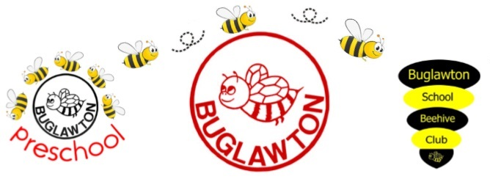
Science Curriculum Statement
INTENT
Rationale:
At Buglawton we believe that all children can achieve in Science. We do not put ceilings on what children can achieve and we do not hold pre-conceptions about any child’s ability to make progress.
We believe through learning Science, children will become enquiry based learners and develop curiosity about natural phenomena, a sense of excitement, predict and analyse.
Ambition:
Our intent is to:
- Build a Science curriculum which develops learning and results in the acquisition of knowledge and builds on previous learning.
- To build a Science curriculum which, enables children to become enquiry based learners.
- Teach Science in a thematic and enjoyable way, alongside other areas of the curriculum
- Children predict, investigate and analyse
- Encourage children to showcase their scientific, investigative and enquiry skills.
IMPLEMENTATION
- Clear and comprehensive scheme of work in line with the National Curriculum.
- A scheme of work that focuses on progressive and enquiry skills and knowledge in the specific disciplines of biology, chemistry and physics.
- Planned opportunities to learn Science within a wider context alongside other curriculum subjects.
- Take time to develop the progression of enquiry skills, predicting, investigating and analysing.
- Opportunity for staff to network with other colleagues through The Ogden Trust and Congleton Partnership
- Extra curricular opportunities to participate in Science.
- Children will be taught Biology, Chemistry, Physics and enquiry skills in a progressive way, year on year.
- Opportunity for children to work independently and collaboratively.
- Learn and use specific and relevant vocabulary.
IMPACT
- We are aspirational for all children, therefore we aim for all children to achieve age related expectations at their end of each academic year.
- Staff will analyse through formative and summative assessments. They will use Headstart assessments at the end of autumn, spring and summer and use DC Pro termly to show children’s progression.
- Children will retain and build on knowledge that is pertinent to Science with a real life context.
- Children will be able to question ideas and reflect on knowledge.
- Children will work collaboratively and practically to investigate and experiment.
- Children will be able to explain the process they have taken and be able to reason scientifically.
- Children will use and understand Science specific vocabulary.

